Analysis
Project title
PocketDeen.
My idea
My idea is an app/website called PocketDeen. It’s an app/ website to help Muslims stay connected to their religion and become better practicing Muslims. It can also help non-Muslims learn about Islam and understand it more. I got this idea because of my belief in Islam, and I would enjoy making something that helps people with their belief or helps people just to gain knowledge of Islam.
This app will contain prayer times, prayer notification and a prayer tracker to help people first to get in touch with the prayers of Islam. Then we will add a google maps API and a compass to both the nearest mosque and to Hajj (pilgrimage)- to make the lives easier for people who use the app/website.

My plan to find out more

- What has inspired me.
I have been inspired been most by my religion (Islam) and I would love to make an app/website to help Muslims and non-Muslims learn more about the religion.

- What kind of thing do I need to find out more about?
I plan to research other Islamic apps and websites to understand what features they include and how they are structured. This will help me decide what is useful, what’s already overused, and what gaps I can fill with PocketDeen. I will also analyse their user interfaces and check reviews to learn what users complain about or wish they had. This research will help guide my design choices and avoid repeating mistakes made by other developers.
- I will ask people questions.

I will speak to members of my local mosque and gather their feedback about what they would like to see in an Islamic app. This will help me understand the real needs of users rather than just based on what I think is useful. Their ideas will allow me to make the app more user-friendly. I also want to ask them about things that are missing from other apps they’ve used, so PocketDeen can fill those gaps.

Analysis: 3 - research
• The 3 products that have choose to take inspiration from.

Figure 1 Pillars
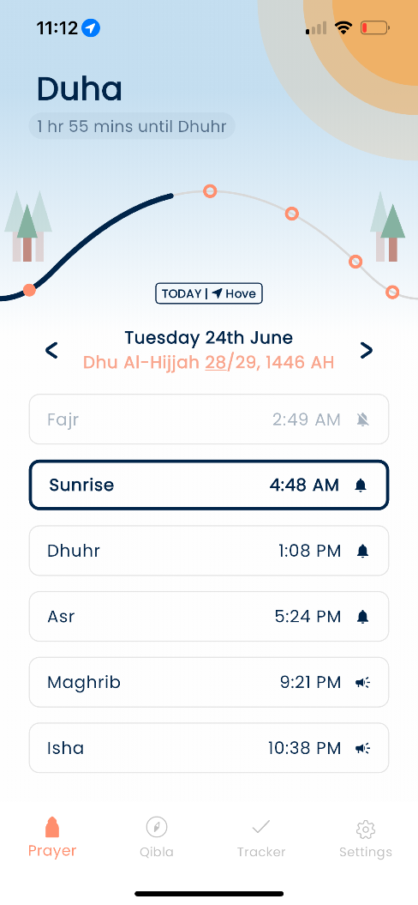

Figure 2 Pillars
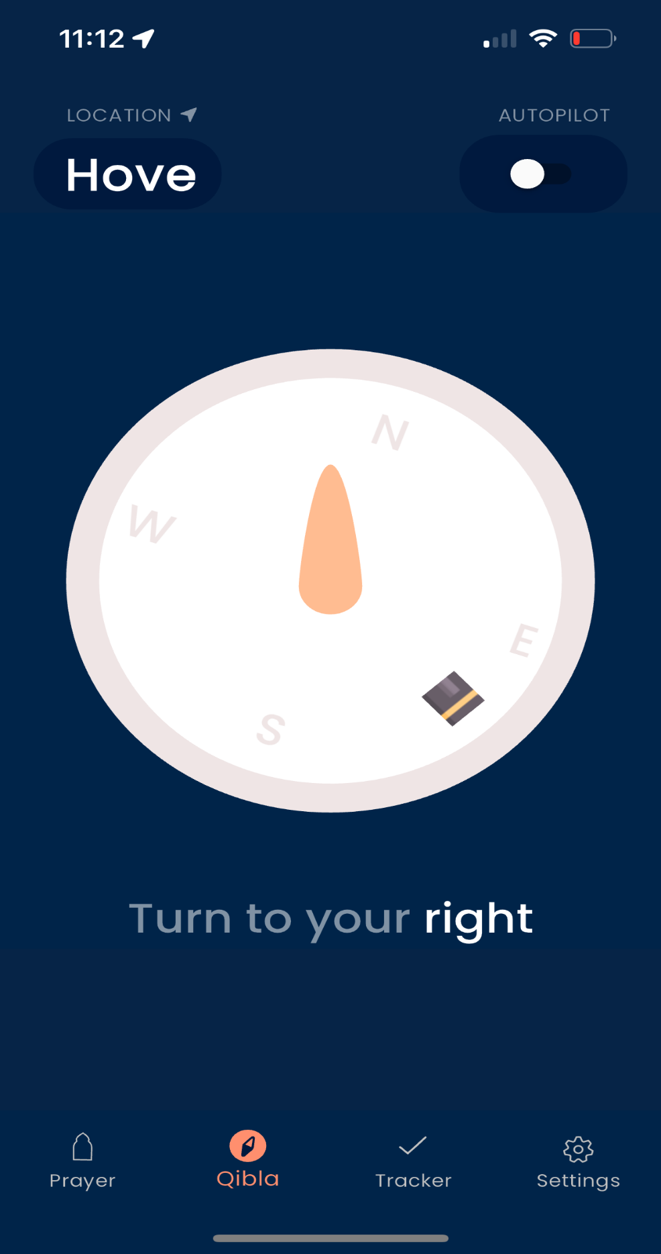

Figure 3 Pillars
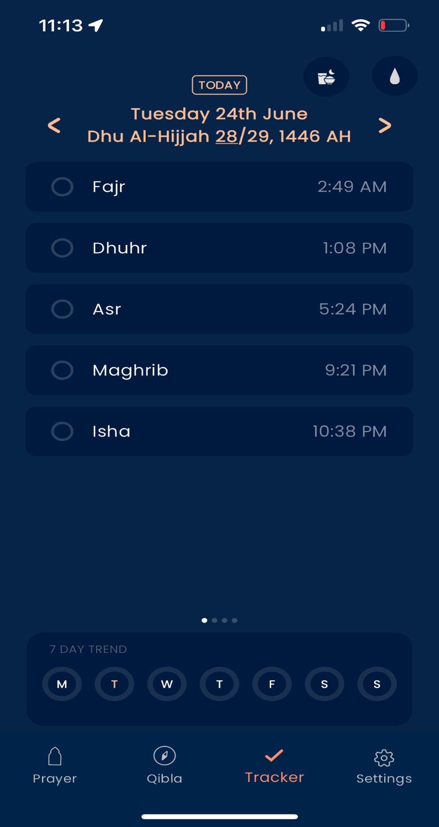

Things would like to take forward/adapt into my project/what I like. | Things I don’t want to use in my project/don’t like.
Nice clean user interface. This app is understandable to any practicing Muslim. | I don’t like its not understandable by non-Muslims. I would make it so
The functions are what I want in my app/website. I like them because they are simple, clean, and easy to use. | The functions are too basic. For non-Muslims, it doesn’t teach them or help them understand the religion.
The compass function is a function that I want to be added. Its clean and simple. I would add a function to direct people to the houses of god(Mosques). | With this function I would just ad more directional text to help non-.
The timings of prayer function are good and minimalistic | I would just make it more inclusive as some people don’t understand that Arabic language like non-don’t know the prayer Maghrib and don’t know how to pray that prayer. (Maghrib is the prayer that you pray at sunset.)

Figure 1 Muslim Pro
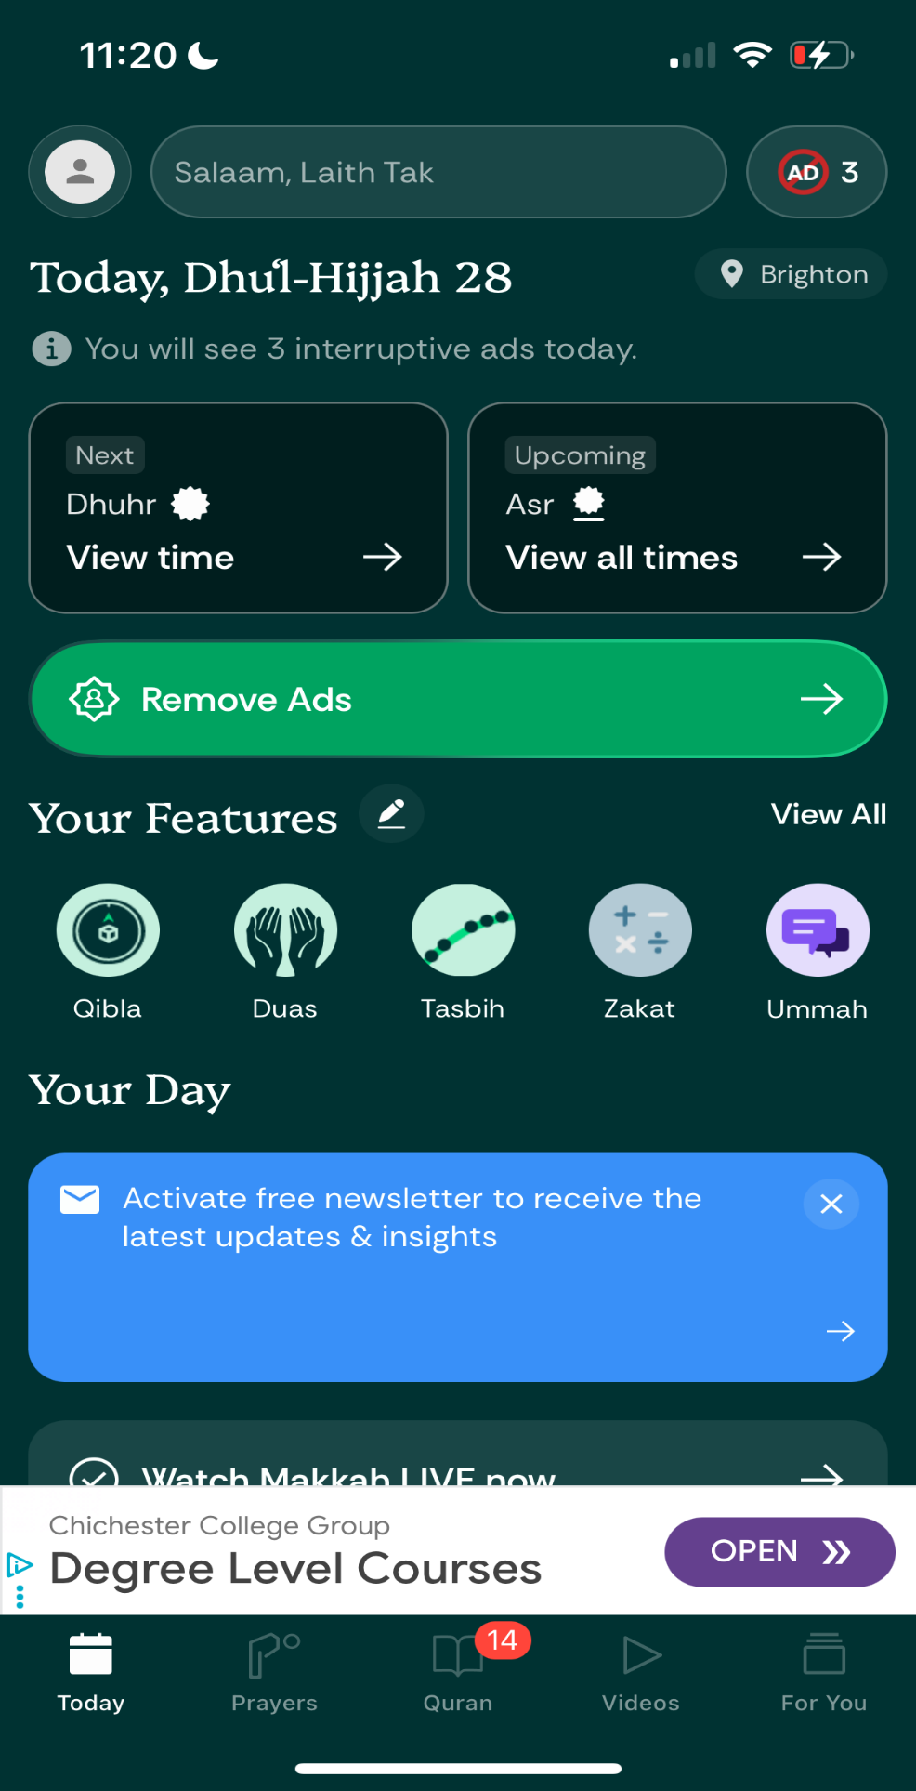

Figure 2 Muslim pro Quran (the holy book for Muslims)

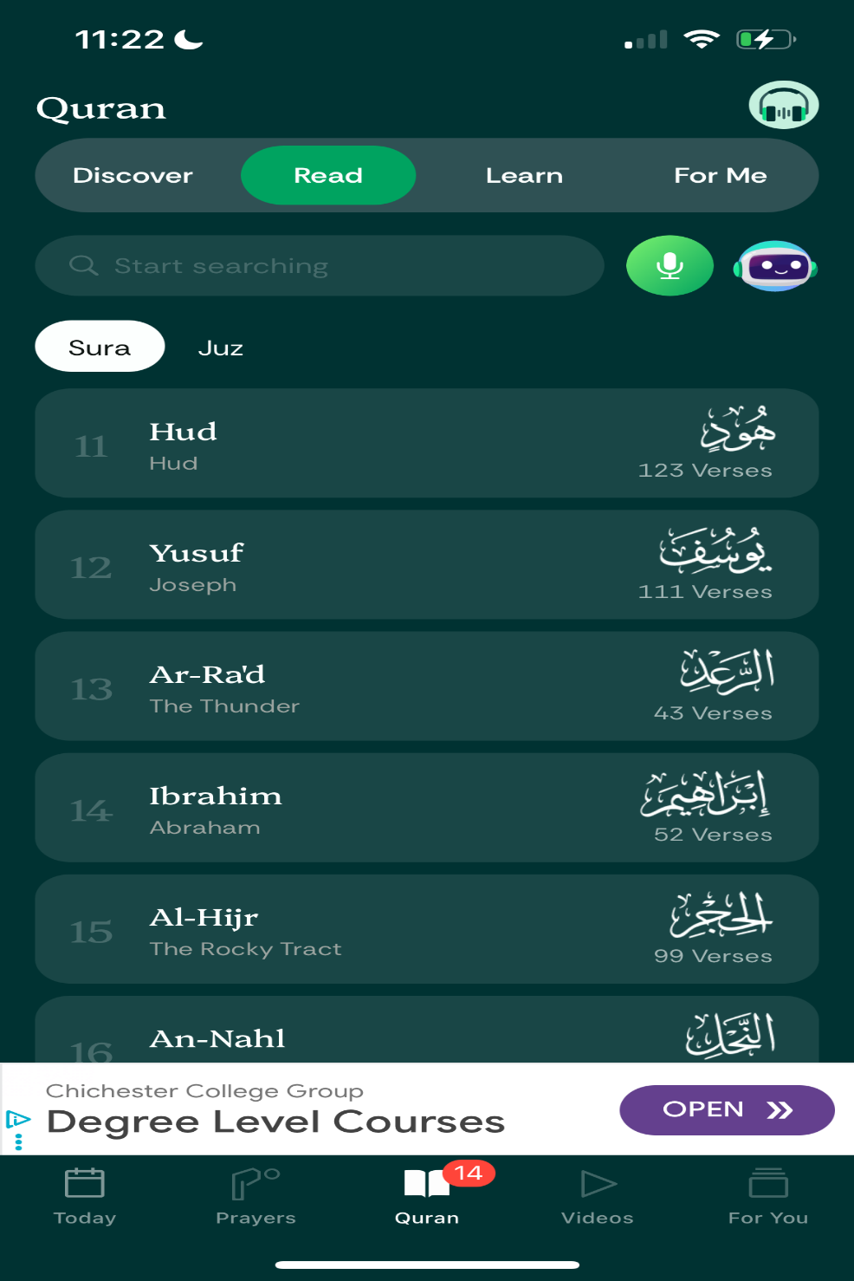

Figure 3 Muslim pro lessons and videos to help people gain more knowledge
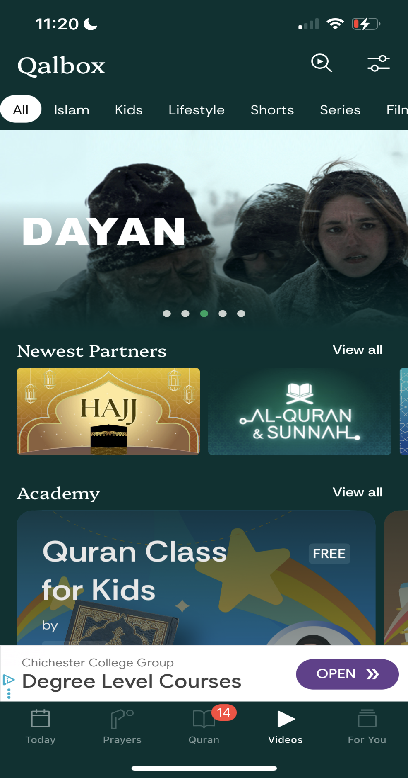

Figure 4 Muslim pro Dua page (Dua means wish)

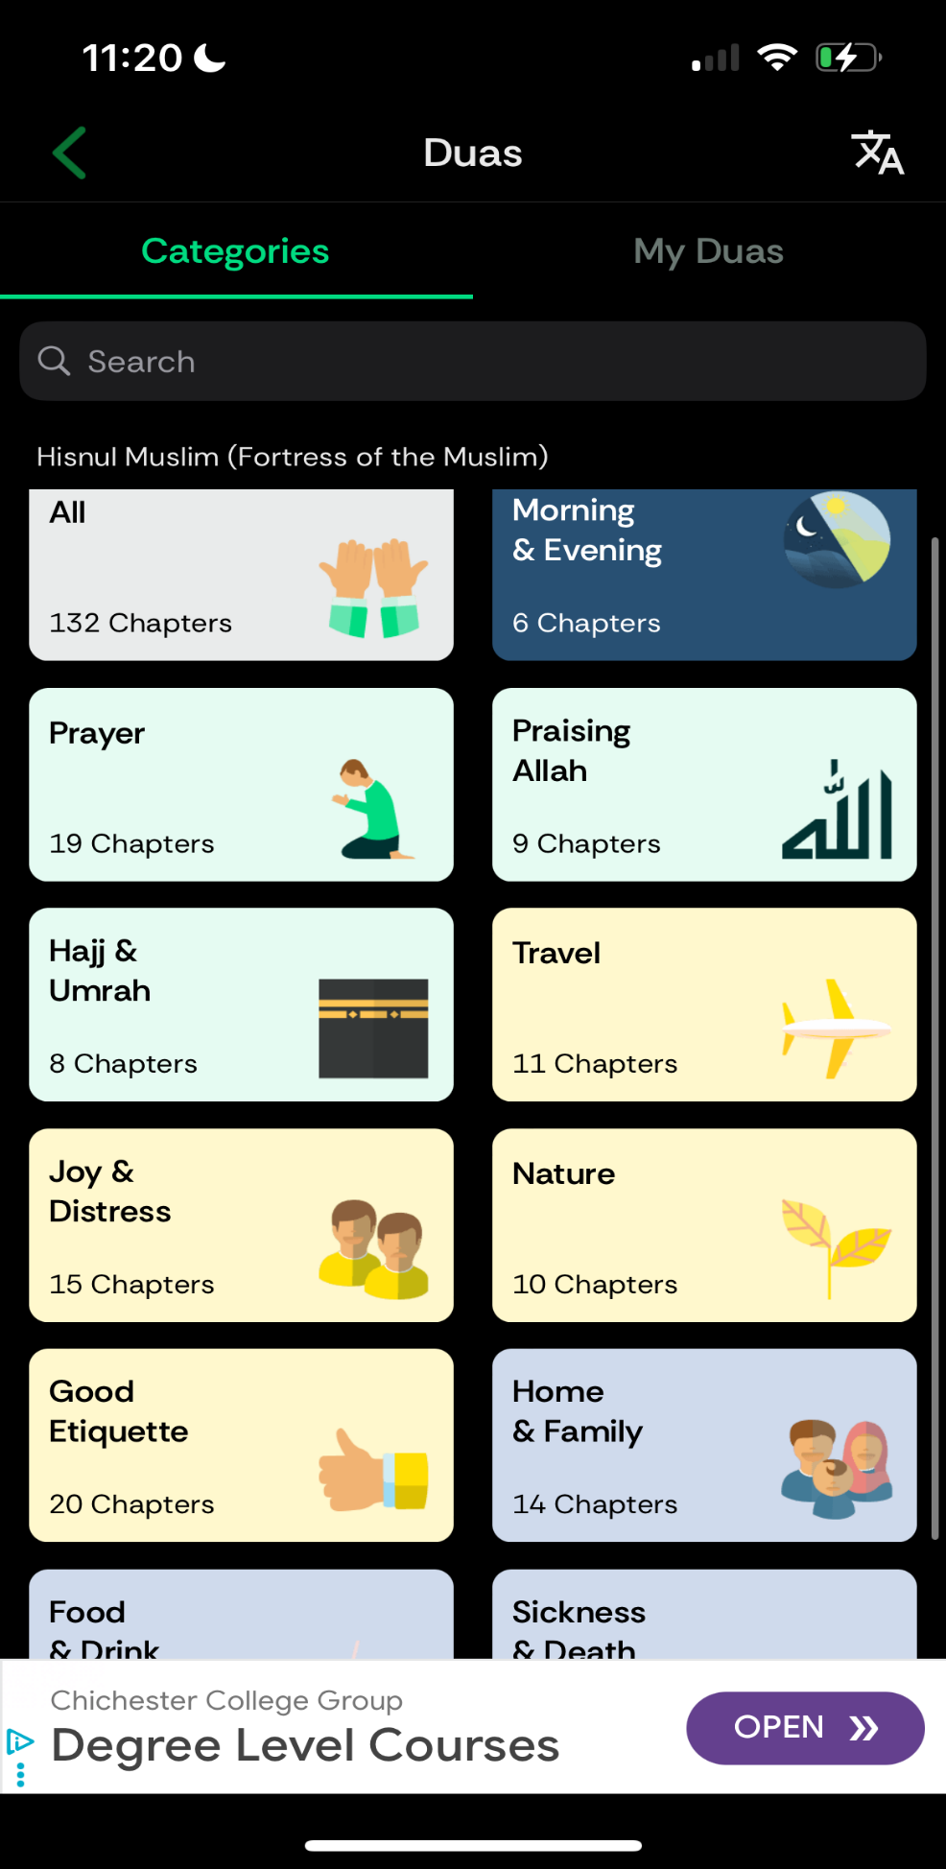
Figure 5 timings of prayer
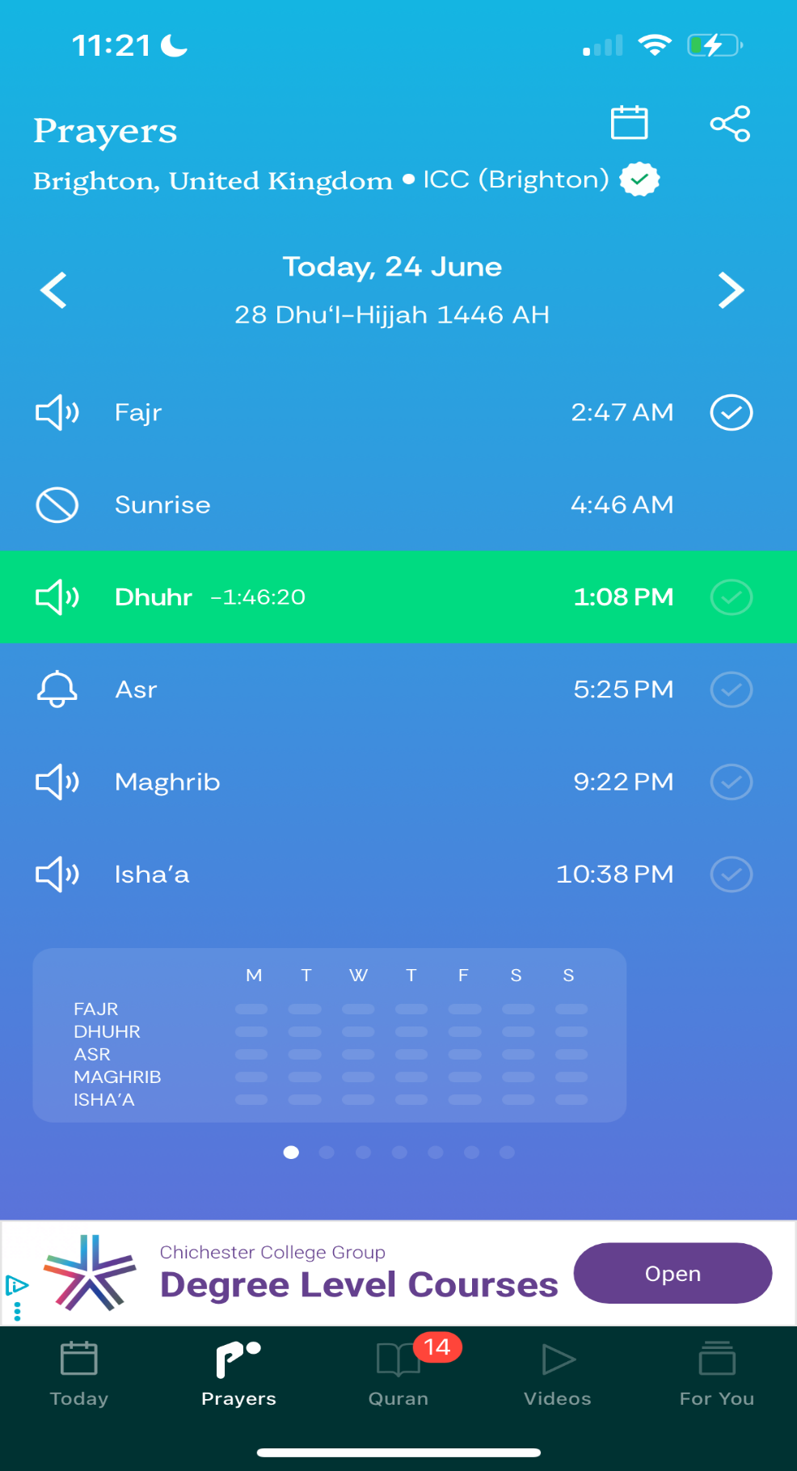

Things would like to take forward/adapt into my project/what I like. | Things I don’t want to use in my project/don’t like.
The front page has a clean and simple interface. The layout is easy to follow, with clear directions that make it easy to use. The colour scheme is minimal and calming, which helps make the app look professional. | The front page still doesn’t have options for people to understand what the Islamic words mean. It’s not inclusive for people who are new to Islam or non-Muslims who want to learn.
The features are nice and easy to use. They are professional and have a clean design. Everything looks well-made and works smoothly. There are a lot of functions that I would like to adapt for my own app, like the tracker and the prayer times. These features help users stay on top of their Deen in a simple way. | Some parts of the app are not explained well for new users. People who don’t know much about Islam might get confused with some of the words or features. It feels like the app was made only for people who already understand the religion.
The Quran feature is easy to read and has bilingual options so you can translate it into your own language. It also has transliteration to help you pronounce the Arabic words properly. There’s even an audio feature where someone reads it out loud, which makes it easier to follow and learn. | The app has endless scrolling, which gets annoying after a while. It makes you feel tired just trying to find the right section. If you accidentally click on a chapter and then go back, it takes you all the way to the top again. This wastes time and makes the experience frustrating.

The dua function is clean and professional. It has searches and buttons that take you to the right place. | Doesn’t have any current things I don’t like
The video feature helps people understand the prophets lives (my peace and blessing be upon them all). they do have English videos to non-Muslims understand. | It not understandable on where to start if your learning about the religion.

Figure 1 muslimandquran - Muslim and Quran - Athan & Prayer Times, Quran, Hadith, Qibla, Ramadan, Dua & More. | Muslim and Quran | Muslim and Quran Home page
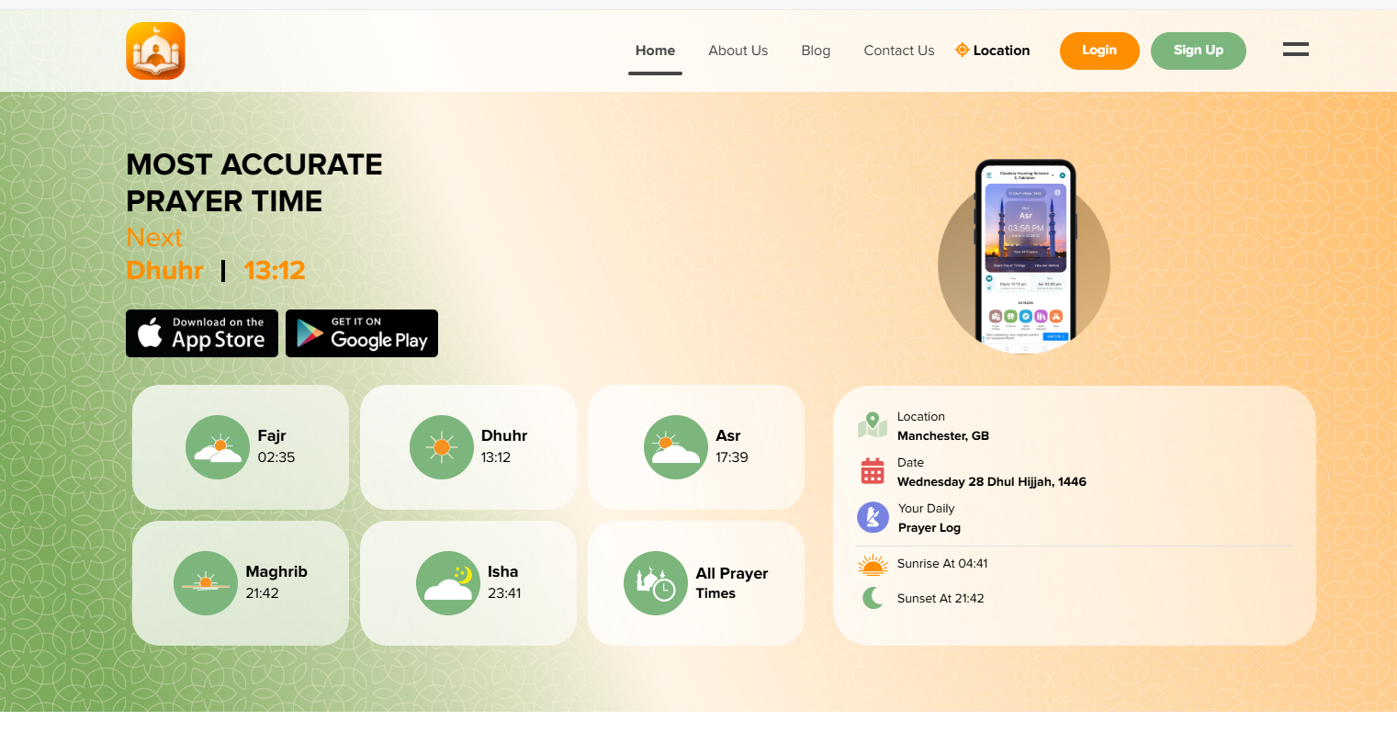

Figure 2 muslimandquran - Muslim and Quran - Athan & Prayer Times, Quran, Hadith, Qibla, Ramadan, Dua & More. | Muslim and Quran | Muslim and Quran features page
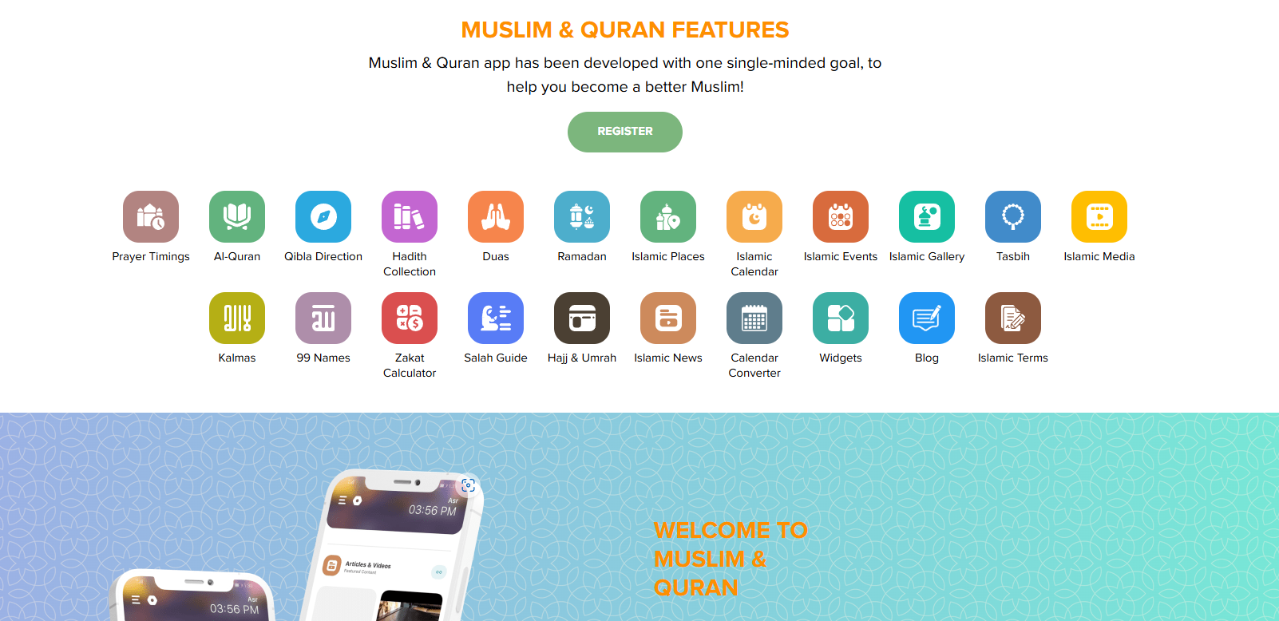

Figure 2 Quran page - https://muslimandquran.com/quran
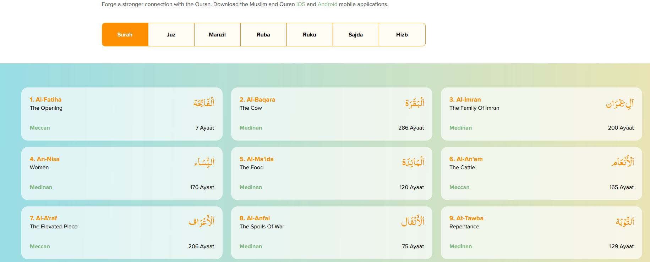

Figure 4 research page -https://muslimandquran.com/islamic-media
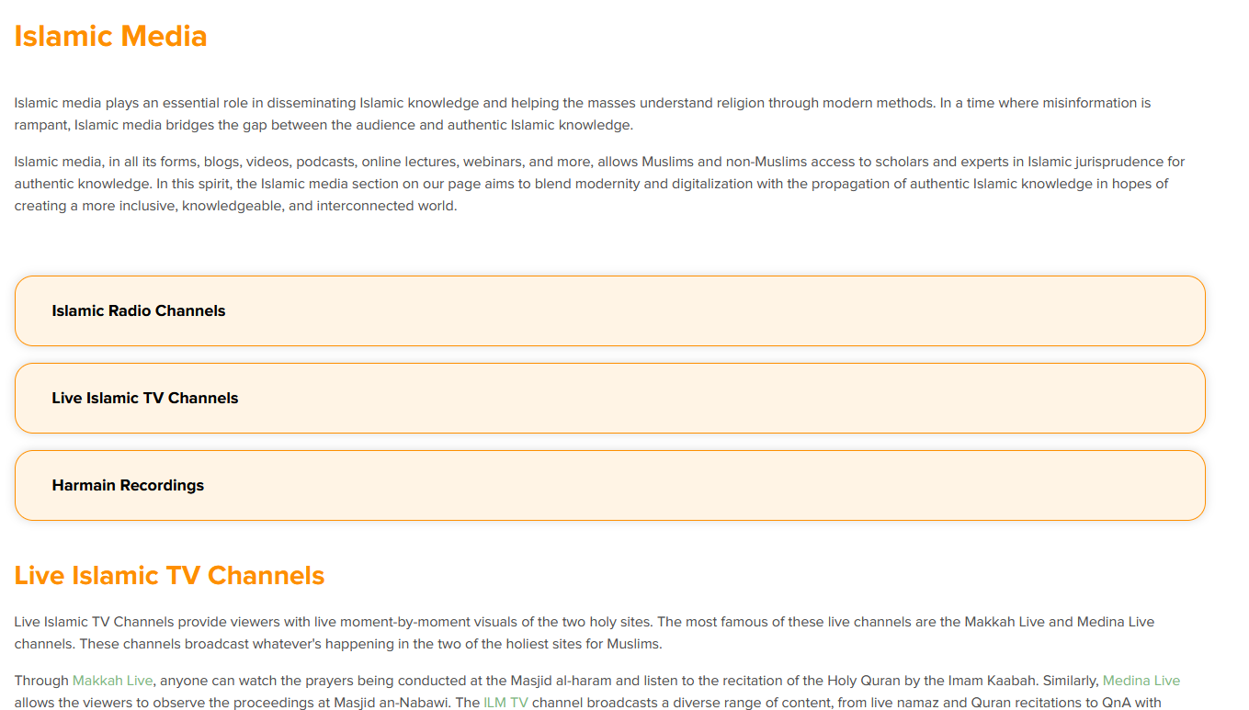

Things would like to take forward/adapt into my project/what I like. | Things I don’t want to use in my project/don’t like.
The front page has a clean and simple design. It uses nice, soft colours that make it look fresh and easy to use. It also supports different languages, which makes it easier for people from different backgrounds to use. It also has a function on how to | N/A. currently I like the front page its clean and simple

The features are nice and easy to use. They are professional and have a clean design. Everything looks well-made and works smoothly. There are a lot of functions that I would like to adapt for my own app, like the tracker and the prayer times. These features help users stay on top of their Deen in a simple way. | Some parts of the app are not explained well for new users. People who don’t know much about Islam might get confused with some of the words or features. It feels like the app was made only for people who already understand the religion.
The Quran feature is easy to read and has bilingual options so you can translate it into your own language. The Quran page has easier access as they are side by side easy to change. | This is on website so there’s not much scrolling issue.
Mosque finder function.  Easy google map’s clear location on direction | N/a
The prayer timing function is clean and simple. It clearly shows all the prayer times for the day, so users know exactly when to pray. It’s easy to read and doesn’t feel confusing or overloaded. This makes it really helpful for both new and regular users. As they have a guid on how to pray | I don’t like the colours used—they’re too plain and don’t stand out. The design feels a bit too simple and could look more modern or engaging. A better colour scheme would make the website more eye-catching and interesting to use.
There is a research page that lets people find an imam (like a priest or a religious guide) to help them learn more about Islam. I like that it gives users a way to ask questions and get proper religious guidance. You can also read articles about Islam, which helps people understand different topics in more detail. I like how it gives both learning and support in one place. | I don’t like this page because it has too much text all in one place. It looks a bit messy and hard to follow, especially for someone new to Islam. There are too many headings, and it’s not always clear where each one goes or what it’s for.

Analysis 4 - Stakeholders

The people who will use the app/website are Muslims who want to be better with there faith and keep track with there prayers. Non-Muslim people who wish to be more knowledgeable in the religion. This is an all-inclusive App to help all people to connect with Islam in an easy way. There is no matter in gender and aimed for people who wish to be more knowledgeable of Islam.

They will be involved in the beginning of the design to help build the foundations of my app/website.

Requirements

I have made a Microsoft form to see what my stakeholders would want to see first.

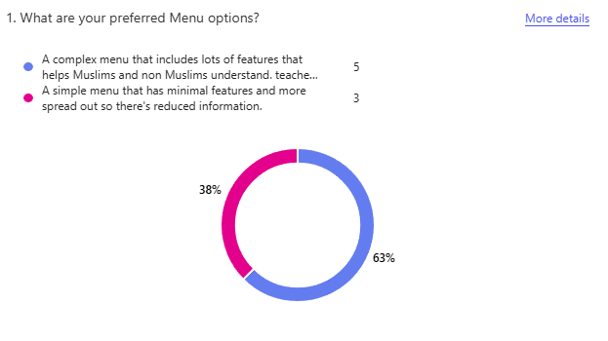

This was to know what my stakeholders where more interested in.
I proposed if they wanted a more complex design or a simpler design to try to best fit their needs.
The complex menu includes lots of features like directions to mosques, how to pray guides and a tracker to help people keep track of their prayers and a lot more.
The simple menu includes a direction to pray, prayer times and a tally(like simplistic features that Muslims need to keep track)
Based on the survey they chose the complex menu.
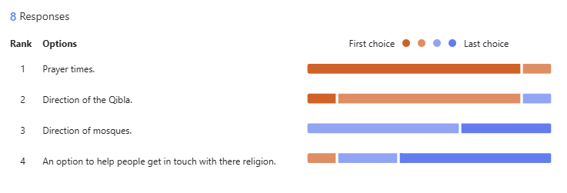
The next task on the survey was to ask my stakeholders what they wanted most.
I gave them a list to place in order depending on what they wanted most.
This was so I can place my priority in jobs my stakeholders wanted first.
They placed it in the order [prayer times, direction of prayer, direction of mosques and an option to help people understand more of the religion].
From my stakeholders responses they wanted to place the functions in first then place the more difficult functions later
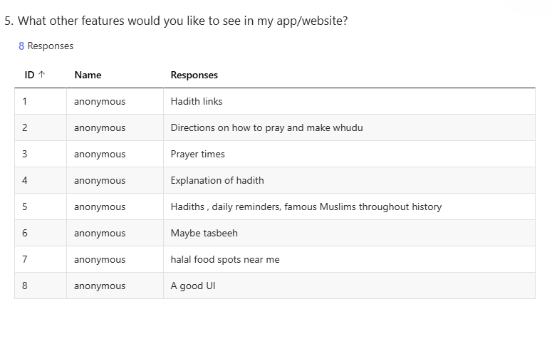
I gave a question to my stakeholders to see if they would want other features so I can try to implement it.

This was so I can further improve my app/website and work on the needs of the stakeholders.

The suggestion I personally liked the most was to include directions to halal food places. However, I understand that this might be challenging to implement, so I plan to add it after I finish working on directions to the nearest mosques.

 | Feature | Explanation | Justification | Importance
1 | A complex design  (Menu) | A Menu where it will display multiple features that will also explain what to do and how to do it. For instance, prayer times would be displayed and there will be an option if they would want a (how to prayer guid) | In the two apps I have researched and the website I realised it was a common function they would display their times of prayer in the front menu. I also realised this what my stakeholders want as they have chosen the complex menu. | Essential
2 | Prayer times | A simple display of the prayer times | This feature was listed first at the top of the survey and was suggested by the stakeholders. It was also included in every app/ website I researched. | Essential

3 | Direction of prayer | A feature that has a compass that points to Kaaba (The place of pilgramage) | Muslims must face the Kaaba in their five daily prayers, as practiced by the Prophet Muhammad (peace be upon him). | essential
4 | Direction of mosques | Allows users to find the nearest mosque. | This was placed number 3 in my survey and helps bring convenience to people
5 | A feature that places a how to(like pray)

Self-assessment
I believe my work is in the range of 5–8 marks. I have identified and described some limitations of the proposed solution, and in some cases I have explained them in more detail. However, I am not fully confident that I have met the standard required to reach the higher tier.

